**Introduction to Database Science**

**Week-1 Project Presentation**

* **Introduce your company**
* **Name**

**Power puff pets**

* **Mission and Vision [important marketing elements]**

Mission:

Spread awareness (diet, spaying and neutering, proper environment, health, etc.)

We provide high quality services and products to our customers

Our mission

to raise awareness about how much pets’ lives matter by providing consultants to pets owners, and to provide an excellent high-quality services and pet care products. Our dedicated and professional staff will ensure a safe, fun, and nurturing environment for your pets while ensuring the best quality and personalized experience for you, and your pet.

Mission statement questions look like:

- What do we do?

- Whom do we serve?

- How do we serve them?

Vision:

Encourage people to be more compassionate with animals,

To be the number one choice for pet owners, to make a world where every pet is happy, healthy, and safe, and to provide the best quality services and products in our country.

Vision statement questions look like:

- What are our hopes and dreams?

- What problem are we solving for the greater good?

- Who and what are we inspiring to change?

* **Service and/or product**

**Services:**

|  |  |
| --- | --- |
| **Current** | **Future** |
| Grooming services | Hotel |
| Consulting services | Daycare |
| Engraving | Vet. (check-ups, vaccines, etc.) |
| Subscription Options (monthly, annual):  Products | Training |
| Membership: Like a loyalty program  Services (grooming, etc.), discounts, priority, new products samples, early access. |  |

**Products:**

* Food (wet food, dry food, seeds, organic options, treats (cookies, biscuits),
* Supplements
* Grooming products (shampoos, nail clippers, brushes)
* Toys
* Cages
* Beds
* Transportations (carriers)
* Accessories (Collars, tags,
* **Years of operation [ could be 0 years if you are raising many to startup the company]**

1 year

* **Market share and list of competition**
* **Pie Chart**

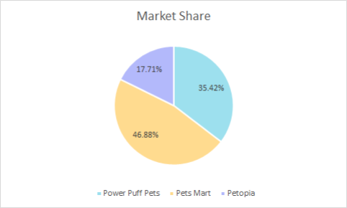

* **Line chart [ increase/ decrease in market share]**
* 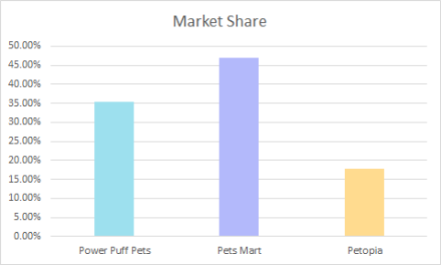
* **Reason for raising additional funds**
* **Why? [list future projects]**

**To expand and own our first store, increase the number of services (day care, hotel, training, and veterinary)**

* **How much? [amount of money you need to raise now and in the future]**

**We need a loan 287 k to be able to expand**

For this we need to estimate and state in detail the cost of prepping and running the future plans.

* **Sara Note: give them a solid explanation in your presentation List additional/new income generated**
* **Plans for payment? [when and how you plan to pay back the money to the investors]**

**List additional/new income generated**

How much are we planning to get from the hotel?

How much are planning to get from the vet.?

How much are we planning to make from training?

How much are we planning to make from daycare?

* **Assuming you will issue bonds**
* **How much interest you plan to offer the investors?**

**Note:**

* **Assuming [on average] banks offer 5% interest on saving accounts [safe investment]**
* **Assuming competition [on average] offer 15% interest on their bonds [risky investment]**
* **Frequency of interest paid [this could be monthly, quarterly, annual depending on your cash flows]**

Monthly or quarterly. I think we need to do the Gold Seek Analysis here?

* **Bond Maturity day [ when will you pay the principal back to your investors]**

**This could be 2 years -5 years**